BANKING PROJECT
Problem Statement :
Develop a basic understanding of risk analytics in banking and financial services and understand how data is used to minimize the risk of losing money while lending to customers.
Solution:
With our dashboards which are created using Power BI latest tools helps the company to make a decision based on the applicant’s profile like if the applicant is likely to repay the loan then approving the loan otherwise not.
About Dataset:
This dataset basically contains information about bank details, various client details which consists of multiple tables which are interlinked with each other through keys like primary key and foreign key.
The various tables are Banking Relationship, Client-Banking, Gender, Investment Advisor and Period.
Data Cleaning:
Handling missing values in Estimated Income and Credit Card Balance to maintain dataset consistency
df['Estimated Income'].fillna(df['Estimated Income'].median(), inplace=True)
df['Credit Card Balance'].fillna(df['Credit Card Balance'].median(), inplace=True)
Removing duplicate client records to ensure unique entries
df = df.drop_duplicates(subset=['Client ID'])
Standardizing Nationality and Occupation columns for uniformity
df['Nationality'] = df['Nationality'].str.title()
df['Occupation'] = df['Occupation'].str.title()
Creating a new column Income Band to categorize clients into Low, Medium, and High income groups
bins = [0, 100000, 300000, float('inf')]
labels = ['Low', 'Med', 'High']
df['Income Band'] = pd.cut(df['Estimated Income'], bins=bins,
labels=labels, right=False)
How did you ensure that each client is uniquely represented?
df = df.drop_duplicates(subset=['Client ID'])
Examine the distribution of unique cataegories in categorical columns
categorical_cols = df[["BRId", "GenderId", "IAId", "Amount of Credit Cards", "Nationality", "Occupation", "Fee Structure", "Loyalty Classification", "Properties Owned", "Risk Weighting", "Income Band"]].columns

for col in categorical_cols:
print(f"value counts for '{col}':")
display(df[col].value_counts())
Calculated Functions:
KPI’S:
- Total Clients
Total Clients KPI represents total number of clients in banking.
Total Clients = DISTINCTCOUNT (‘Clients – Banking’[ ClientID ] )
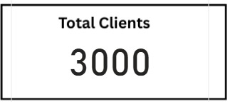
- Total Loan
Total Loan gives you information about the bank loan+ Business Lending+ Credit cards balance of particular investor, gender.

Total Loan = [Bank Loan] +[Business Lending] +[Credit Cards Balance]

- Bank Loan
Bank Loan gives you information what is the loan amount of loan to be repaid by the client to bank.

Bank Loan = SUM( ‘Clients – Banking’[Bank Loans] )
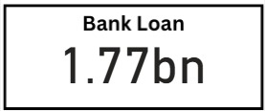
- Business Lending
Business Lending gives you information about the loan amount given to small business.

Business Lending = SUM( ‘Clients – Banking’[Business Lending] )
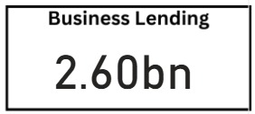
- Total Deposit
Total Deposit gives you information about the amount deposited by particular investors in bank.

Total Deposit = [Bank Deposit] + [savings Account] + [Foreign Currency Account] + [Checking Accounts]
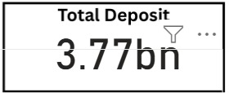
- Bank Deposit
Bank Deposit is the put in the bank.

Bank Deposit = SUM( ‘Clients – Banking’[Bank Deposits] )
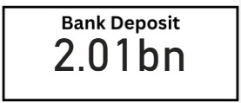
- Checking Account Amount
Checking Account Amount is nothing but which offers easy access to your money for daily transactional needs.

Checking Accounts = SUM( ‘Clients – Banking’[Checking Accounts] )
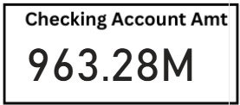
- Savings Account Amount
Savings Account is an interest-bearing deposit account held at a bank.

Savings Account = SUM( ‘Clients – Banking’[Savings Account] )
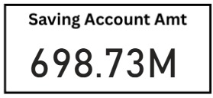
Visualization and Result:
Home
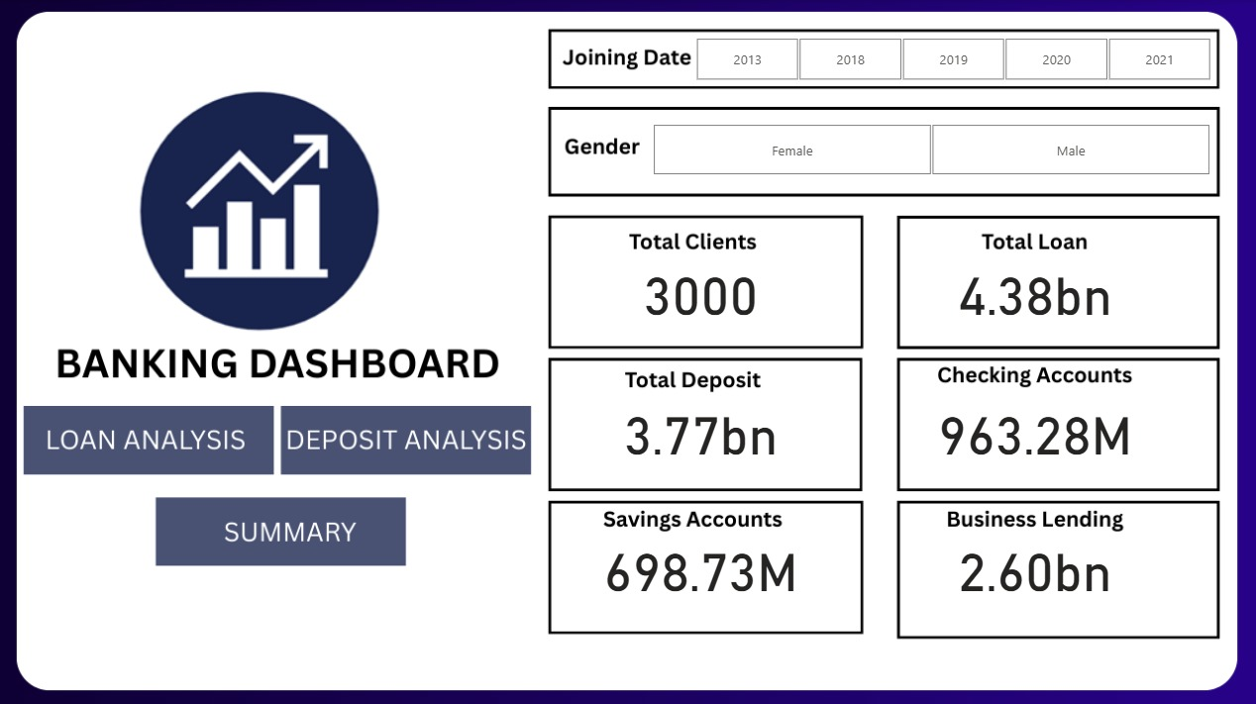
Loan Analysis
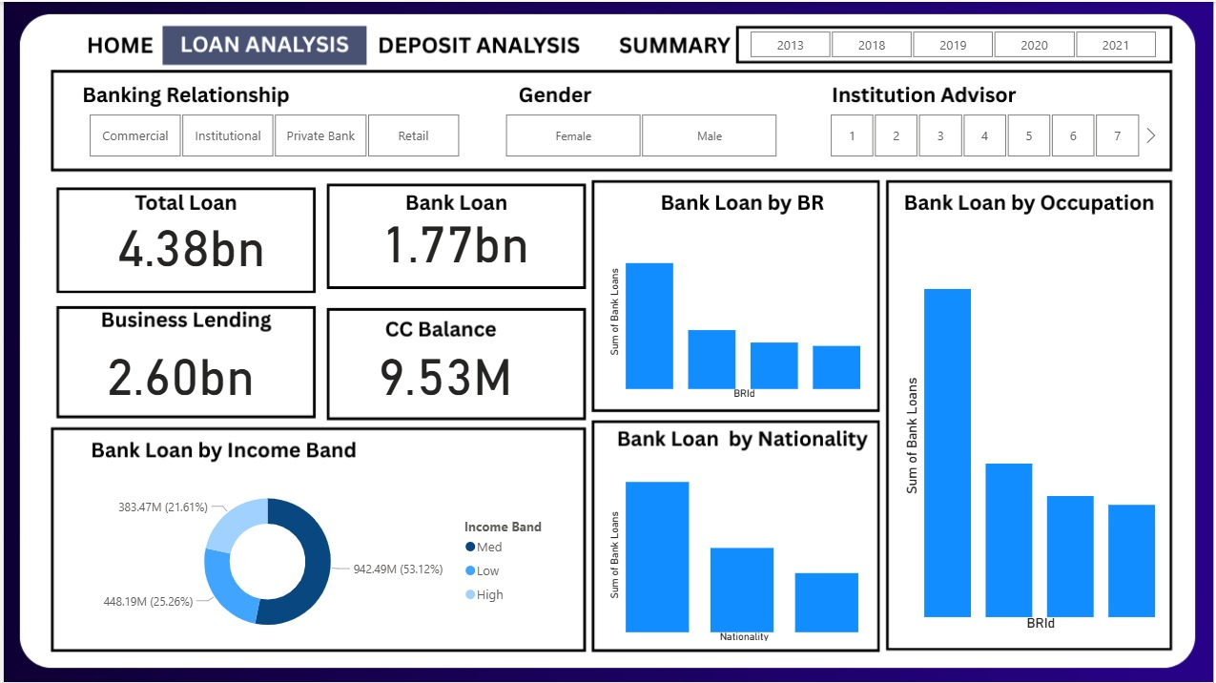
Deposit Analysis
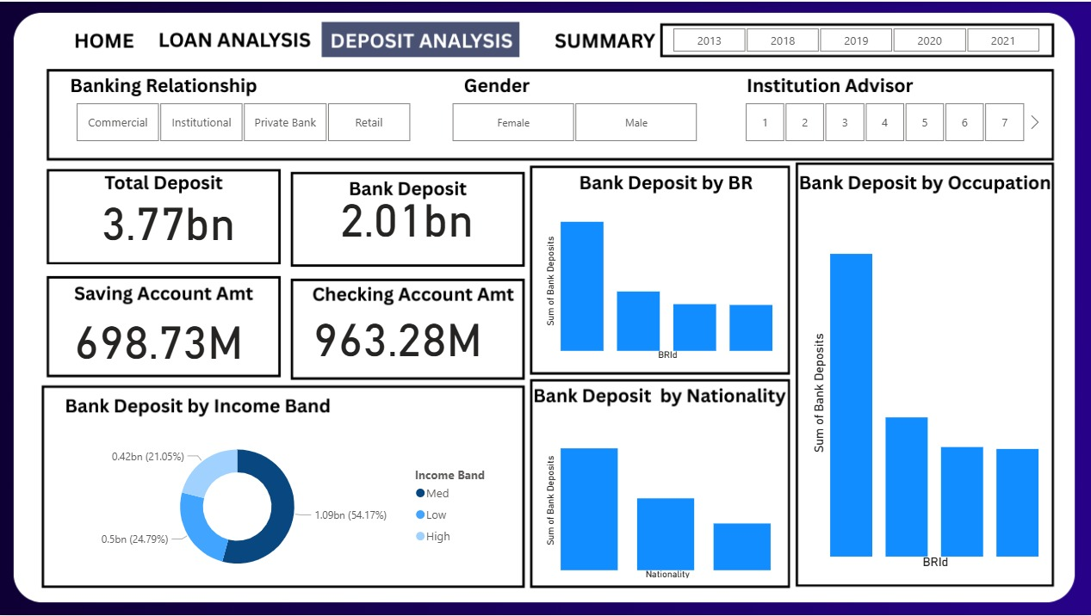
Summary Dashboard
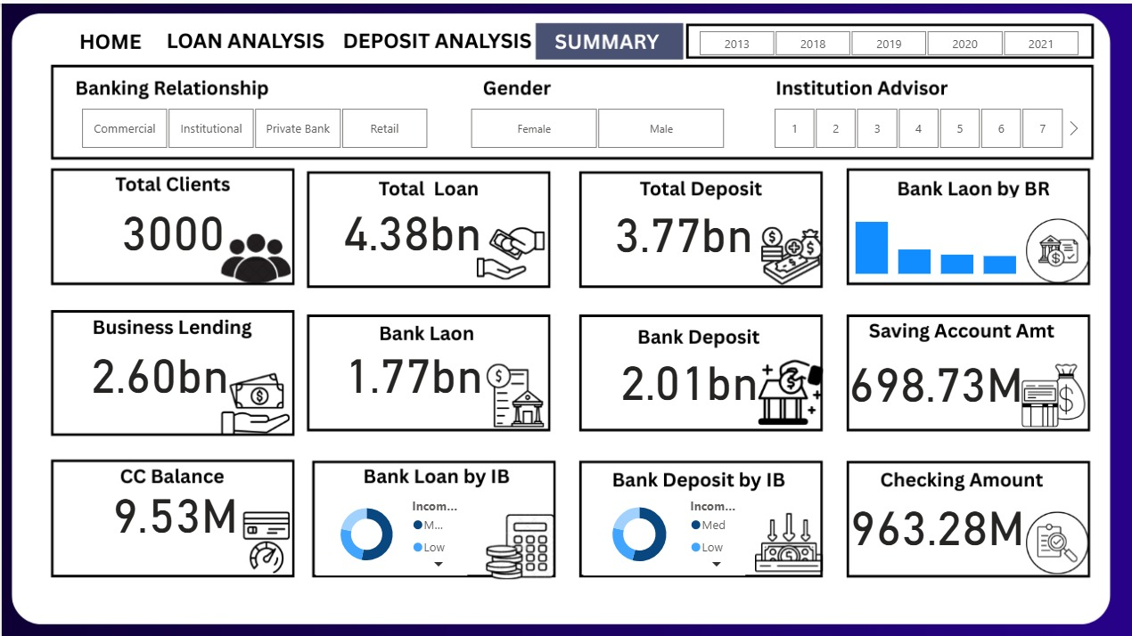
Conclusion
Empowered by the latest data visualization techniques, Power BI dashboards are among the most effective resources for using in banking sector. As outlined in this write-up, a banking operations dashboard in Power BI can be developed with key banking related ,metrics and KPIs.
Future Work
- With these dashboards banks can easily know what is the total loan amount and all other things of a particular investor.

- It also helps which type of banks have more number of clients as we can see private banks have more number of clients so it can helps other banks can build their strategies to increase clients.

- It also provides insights about which nationality has highest bank loans.

- It gives information about various types of amount involved in different types of accounts by investors.

